Part Number: PU322-61015-WH

Kit Contents
Item # | Quantity Reqd. | Description
1 | 1 | Trailer Module Harness
2 | 1 | Trailer Sub-Wire Harness (4-Flat)
3 | 1 | Trailer Power Wire Harness
4 | 1 | Mounting Bracket, 4-Flat
5 | 2 | Screw #10-24
6 | 2 | Nut/Washer #10-24
7 | 45 | Wire Tie 8”
8 | 8 | Foam-Pad
9 | 1 | Fuse Location Card
10 | 1 | Owner’s Manual
Hardware Bag Contents
Item # | Quantity Reqd. | Description
1
2
3
Additional Items Required For Installation
Item # | Quantity Reqd. | Description
1 | 1 | Towing Hitch
2
3
Conflicts
Recommended Sequence of Application
Item # | Accessory
1 | Towing Hitch (NOTE: Do NOT reinstall vehicle parts until the Trailer Wire Harness is installed)
2 | Trailer Module Harness
3 | Trailer Power Wire Harness
4 | Trailer Sub-Wire Harness (4-Flat)
*Mandatory
Vehicle Service Parts (may be required for reassembly)
Item # | Quantity Reqd. | Description
1
2
3
Recommended Tools
Personal & Vehicle Protection | Notes
Safety Glasses
Vehicle Protection | Cloth/Rag
Protective Tape
Special Tools | Notes
Circuit Tester
Installation Tools | Notes
Ratchet | 3/8” Drive, Medium Extension
Socket | 10mm, 3/8” Drive
Trim Panel Remover Tool
Screwdriver | Small Flat, Phillips #2
Pliers | Side Cutter
Wrench | 10mm
Clip Remover
Torque Wrench | 5.4 N•m (48 lbf•in) to 8.4 N•m (74 lbf•in)
Plastic Scraper
Metal Saw
Special Chemicals | Notes
VDC Approved Cleaner
General Applicability
Legend
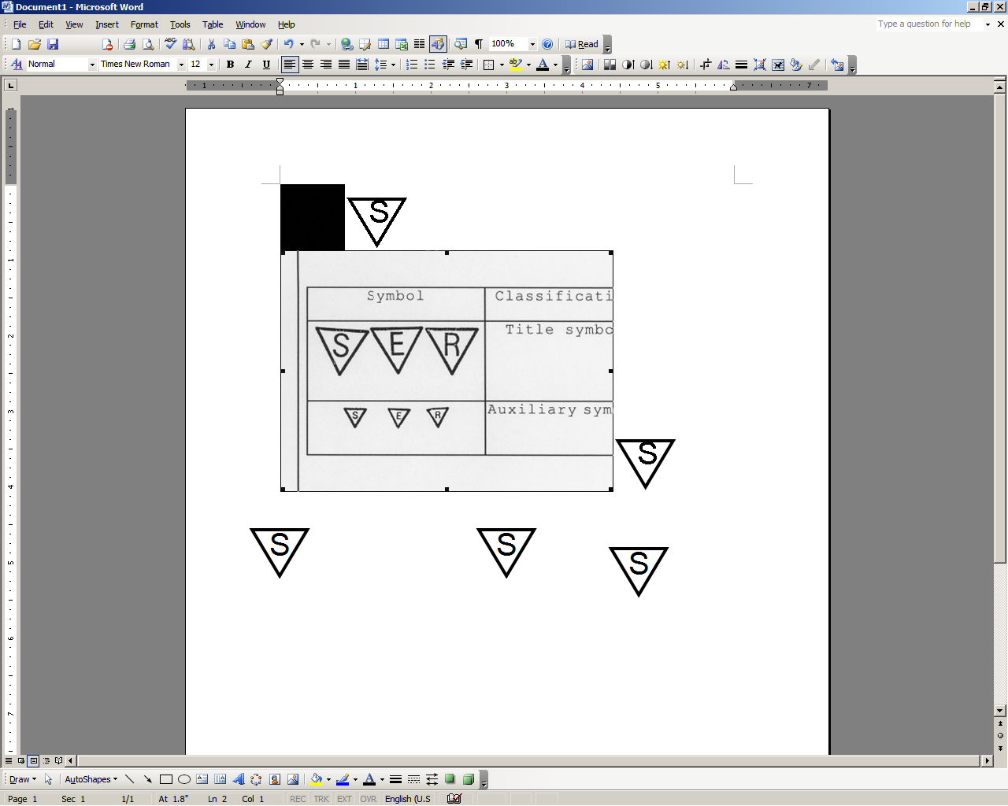




STOP: Damage to the vehicle may occur. Do not proceed until process has been complied with.
OPERATOR SAFETY: Use caution to avoid risk of injury.
CAUTION: A process that must be carefully observed in order to reduce the risk of damage to the accessory/vehicle and to ensure a quality installation.
TOOLS & EQUIPMENT: Used in Figures calls out the specific tools and equipment recommended for this process.
REVISION MARK: This mark highlights a change in installation with respect to previous issue.
SAFETY TORQUE: This mark indicates that torque is related to safety.

Care must be taken when installing this accessory to ensure damage does not occur to the vehicle. The installation of this accessory should follow approved guidelines to ensure a quality installation.

These guidelines can be found in the "Accessory Installation Practices" document.

This document covers such items as:-
- Vehicle Protection (use of covers and blankets, cleaning chemicals, etc.).
- Safety (eye protection, rechecking torque procedure, etc.).
- Vehicle Disassembly/Reassembly (panel removal, part storage, etc.).
- Electrical Component Disassembly/Reassembly (battery disconnection, connector removal, etc.).

Please see your Lexus dealer for a copy of this document.

Trailer Wire Harness – Installation Outline

Ground
Trailer Electronic Module
T-connection to Rear Comb Lamp RH
B+ Terminal to Battery
4-Flat Connector
Front of Vehicle
T-connection to Rear Comb Lamp LH
Trailer Power Wire Harness
Trailer Module Harness
Trailer 4-Flat Harness

Disassemble the Vehicle.
  - Remove the rear bumper cover and the interior cargo compartment components (i.e. tonneau cover assembly, deck board assembly, rear deck trim cover and deck floor boxes LH and RH) as illustrated in the Tow Hitch installation instructions from Step 3(a) to Step 3(e) of the vehicle disassembly section.
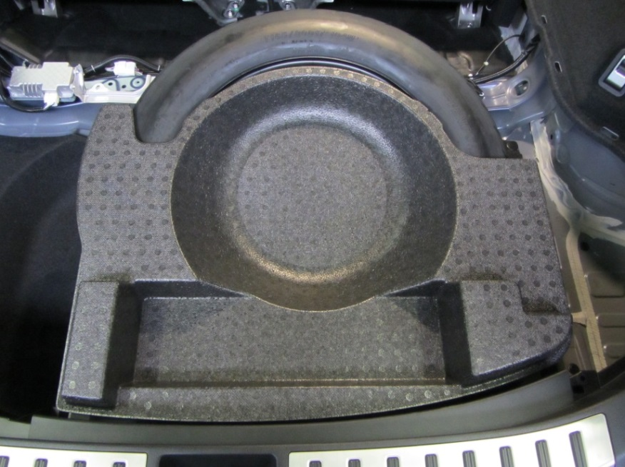
  - Remove the Styrofoam tray from the top of the spare tire (Fig. 1-1).
Fig. 1-1
  - Remove the deck floor box.
    - Fold the back of the rear seat forward.

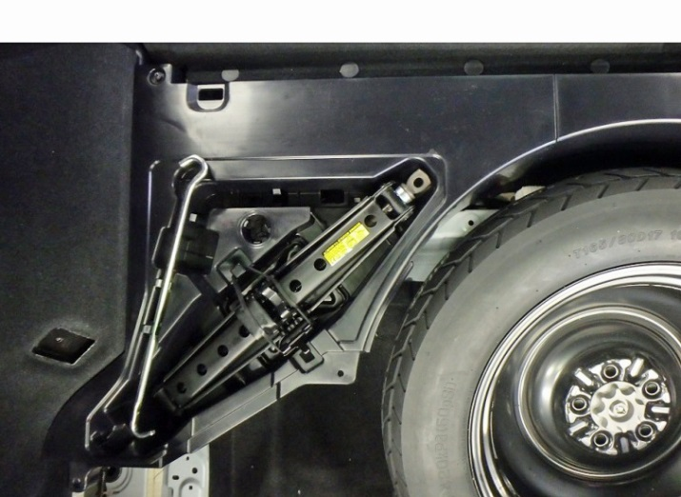
    - Remove the three clips (Fig. 1-2).
Fig. 1-2
Clip remover & #2 Philips screwdriver
    - Remove the screw ( Fig. 1-2).

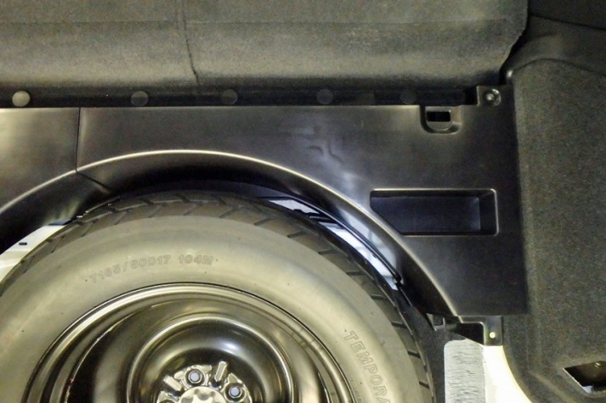
    - Remove the four clips (Fig. 1-3).
Fig. 1-3
Clip remover & #2 Philips screwdriver
    - Remove the screw ( Fig. 1-3).

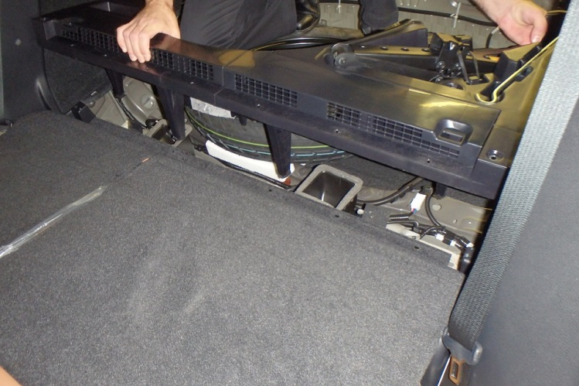
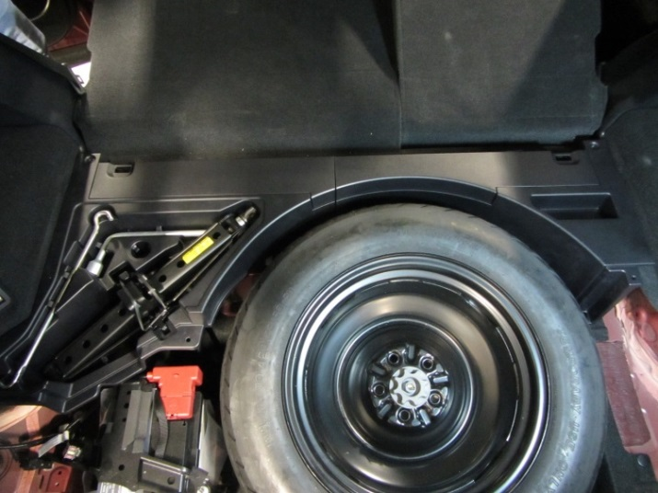
  - Pull the box to disengage the three clips attached to vehicle floor and remove the box assembly (Fig. 1-4 and Fig. 1-5).
Fig. 1-5
Fig. 1-4

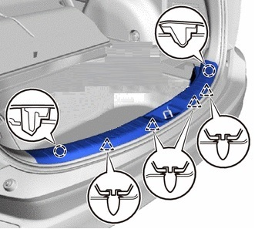
  - Detach the two claws ( ) and four clips () to remove the rear floor finish plate (Fig 1-6).
Fig. 1-6

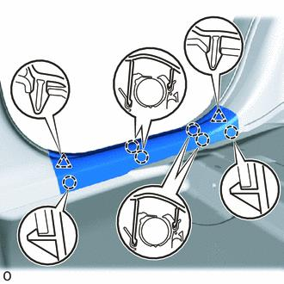
  - Detach the two clips () and six claws ( ); then remove the rear door scuff plate LH (Fig. 1-7).
Fig. 1-7

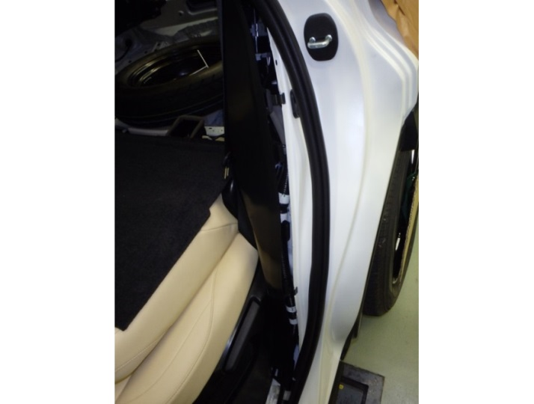
  - Partially remove the weather strip from the rear door LH in the wheel house area (Fig. 1-8).
Fig. 1-8

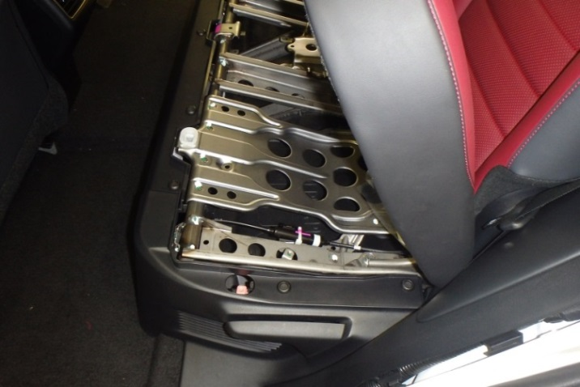
  - Remove the trim panel on the side of the rear seat LH to allow the removal of the deck trim side panel assembly LH (Fig. 1-9).
Fig. 1-9
    - Raise the LH seat back to the upright position.
    - Lift the rear seat up (Fig. 1-9).

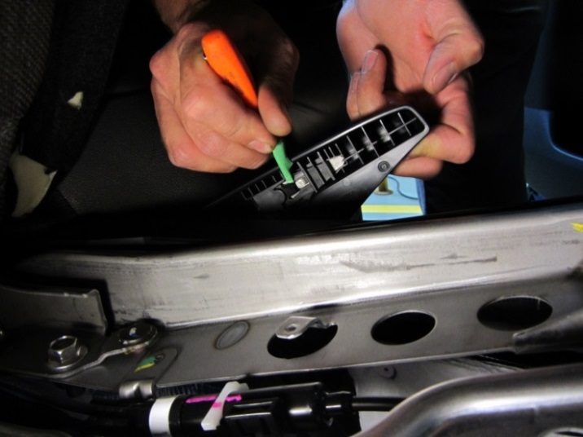
    - Manual Seat Only: Lift the reclining adjuster release handle LH to gain access to its retaining lock. Use a small screwdriver to lift the retaining lock and remove the handle (Fig. 1-10).
Fig. 1-10
Small flat screwdriver
HINT: Tape the screwdriver tip.

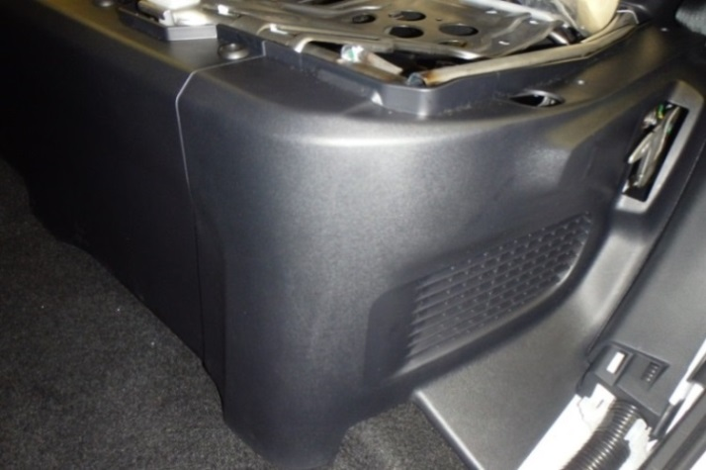
    - Remove the two push pins on the top of the side panel ( Fig. 1-11).
Fig. 1-11
Small flat screwdriver

    - Disengage the two clips in front of the side panel and remove the rear seat side panel LH (Fig. 1-11).

  - Detach the two clips () and six claws ( ); then remove the rear door scuff plate RH (Fig. 1-12).
Fig. 1-12

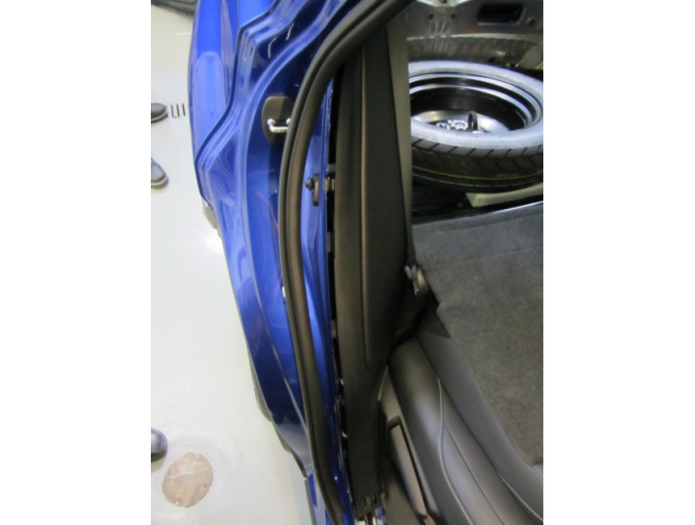
  - Partially remove the weather strip from the rear door RH in the wheel house area (Fig. 1-13).
Fig. 1-13

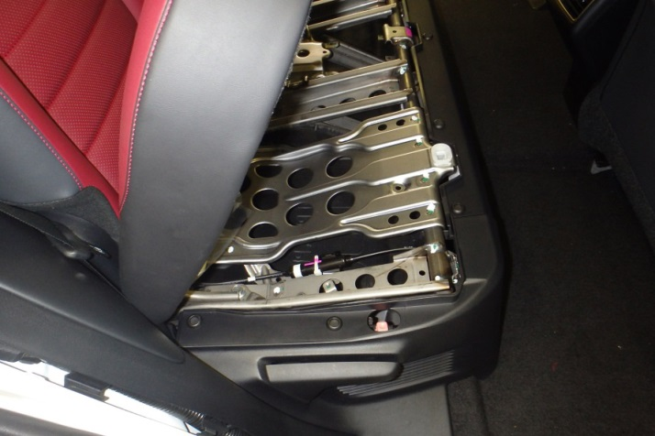
  - Remove the trim panel on the side of the rear seat RH to allow the removal of the deck trim side panel assembly RH (Fig. 1-14).
Fig. 1-14
    - Raise the RH seat back to the upright position.
    - Lift the rear seat up (Fig. 1-14).

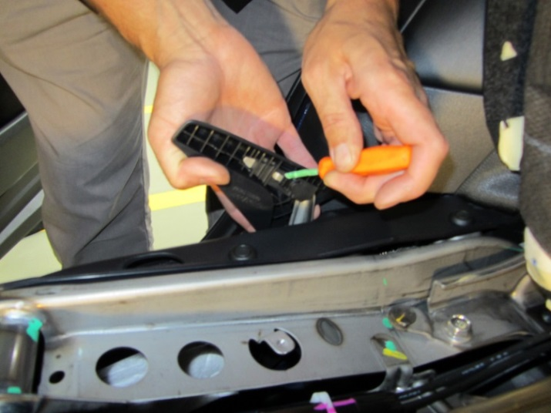
    - Manual Seat Only: Lift the reclining adjuster release handle RH to gain access to its retaining lock. Use a small screwdriver to lift the retaining lock and remove the handle (Fig. 1-15).
Fig. 1-15
Small flat screwdriver

HINT: Tape the screwdriver tip.

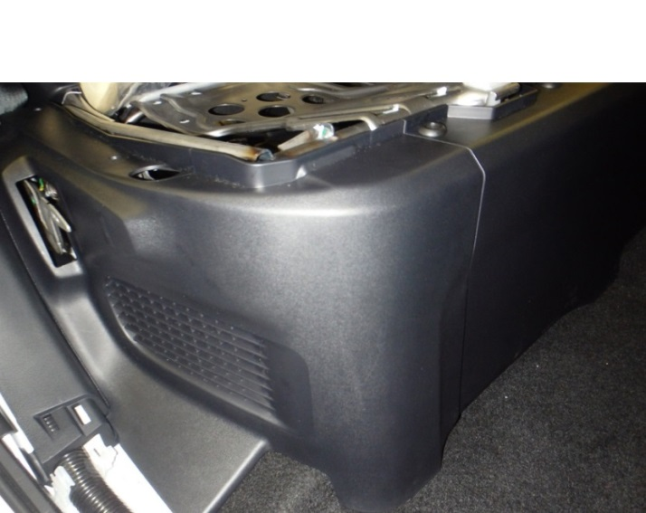
    - Remove the two push pins on the top of the side panel ( Fig. 1-16).
Fig. 1-16
Small flat screwdriver

    - Disengage the two clips in front of the side panel and remove the rear seat side panel RH (Fig. 1-16).

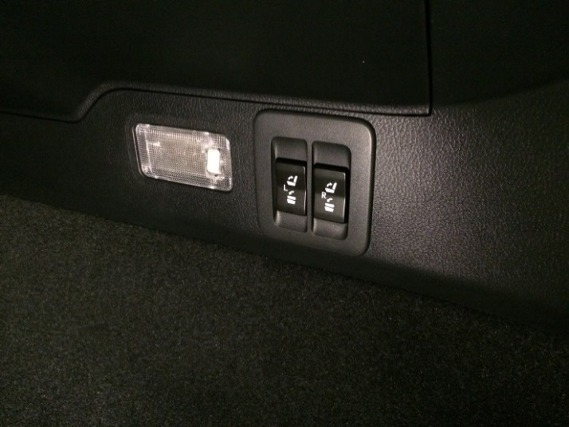
  - Use the switches in the RH deck trim side panel assembly to lower the LH and RH seat backs (Fig. 1-17).
Fig. 1-17
  - Move the power driver seat (if equipped) forward, just enough to access and remove the lower front seat belt bolt LH.

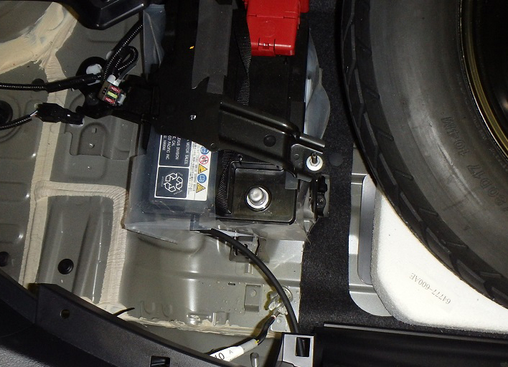
  - Use a 10 mm wrench to disconnect the negative (-) battery terminal from the battery and isolate the negative battery terminal (Fig. 1-18).
Fig. 1-18
10mm wrench or socket & ratchet

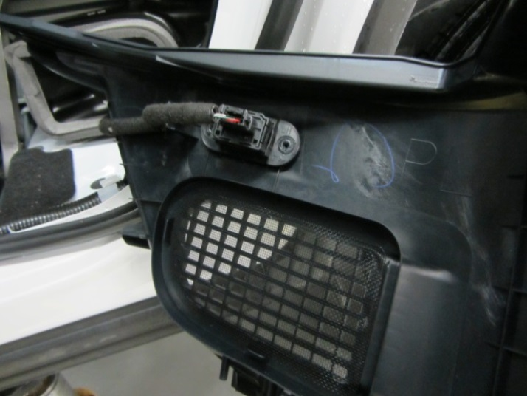
  - Power Seat Only: Disconnect the power seat switches and remove the clip from the seat side panel LH (Fig. 1-19).
Fig. 1-19

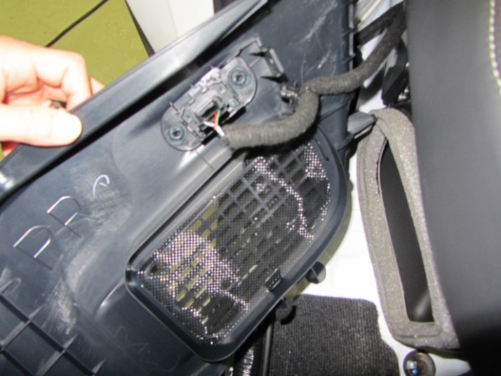
  - Power Seat Only: Disconnect the power seat switches and remove the clip from the seat side panel RH (Fig. 1-20).
Fig. 1-20

  - Remove the deck trim side panel assembly LH.
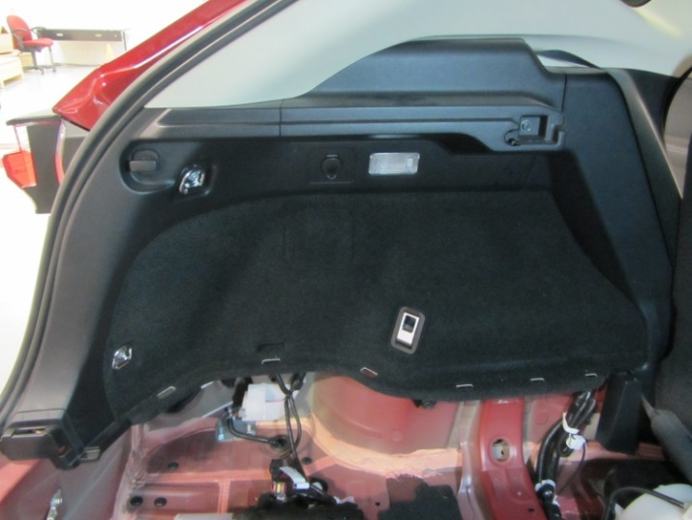
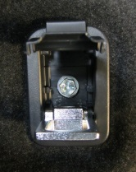
    - Open the tether anchor set bracket cover (Fig. 1-21).
Fig. 1-21
10mm socket, extension & ratchet; Phillips screwdriver
D-Ring (x2)
Bolt
Tie down Hook
    - Remove the bolt and tether anchor set bracket (Fig. 1-21 insert).
    - Remove the bolts and the two D-Rings (Fig. 1-21).
    - Push the tie down hook and turn it 90 degrees to have the squeezable tab on top, then press the tab and pull the hook to remove it (Fig. 1-21).
    - Remove the bolt that secures the upper trim sub-panel (Fig. 1-21).
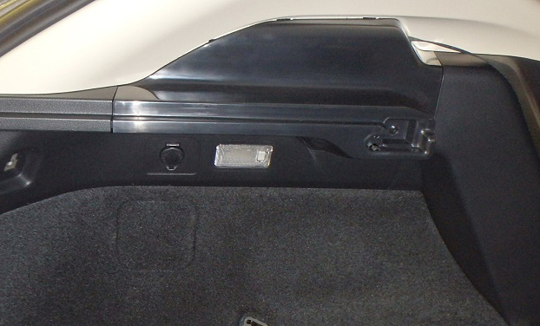
    - Pull the upper panel to disengage all eleven clips and remove the panel (Fig. 1-22).
Fig. 1-22

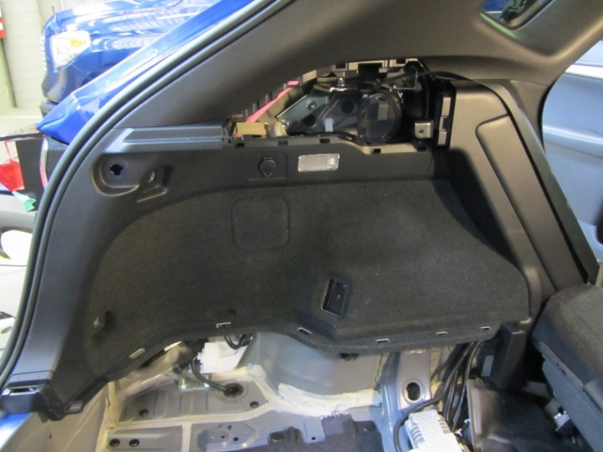
    - Disengage the eight clips to displace the deck trim side panel assembly LH (Fig. 1-23).
Fig. 1-23
    - Disconnect the electrical connectors for the cargo lamp and power outlet, and then remove the deck trim side panel assembly LH by pulling it rewards.

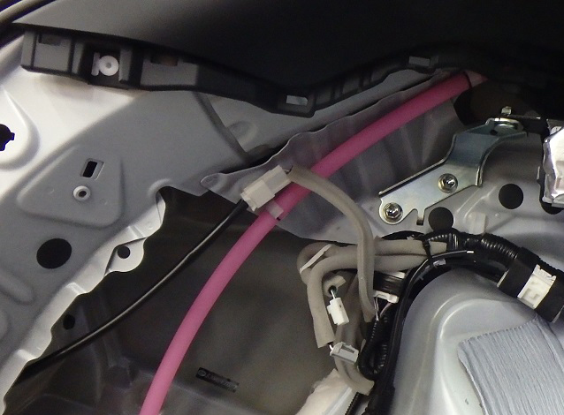
  - Disconnect the 4 pin in-line electrical connector to LH rear combination lamp assembly (Fig. 1-24).
Fig. 1-24

  - Remove the deck trim side panel assembly RH.
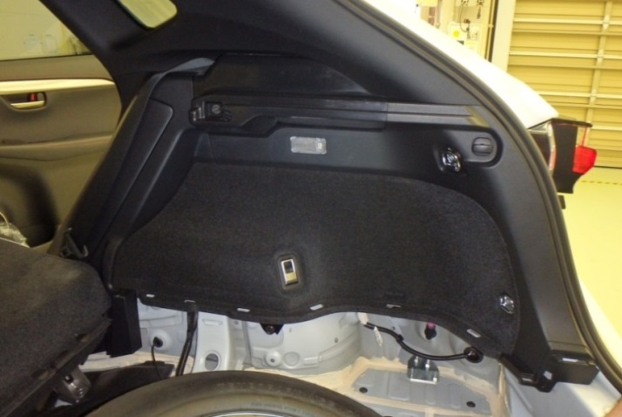
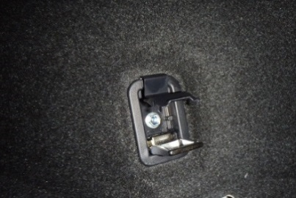
    - Open the tether anchor set bracket cover (Fig. 1-25).
Fig. 1-25
10mm socket, extension & ratchet; Phillips screwdriver
D-Ring (x2)
Bolt
Tie down Hook
    - Remove the bolt and tether anchor set bracket (Fig. 1-25 insert).
    - Remove the bolts and the two D-Rings (Fig. 1-25).
    - Push the tie down hook and turn it 90 degrees to have the squeezable tab on top, then press the tab and pull the hook to remove it (Fig. 1-25).
    - Remove the bolt that secures the upper trim sub-panel (Fig. 1-25).
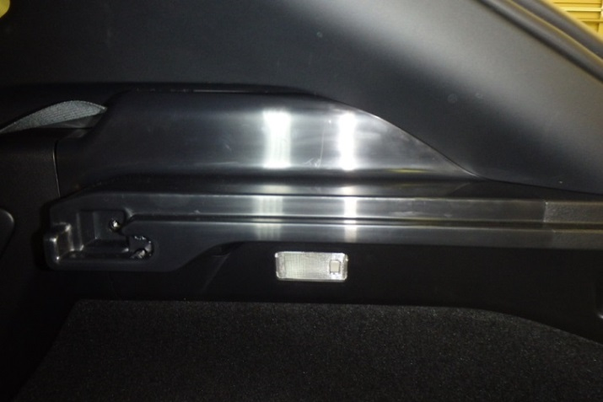
    - Pull the upper panel to disengage all eleven clips and remove the panel (Fig. 1-26).
Fig. 1-26

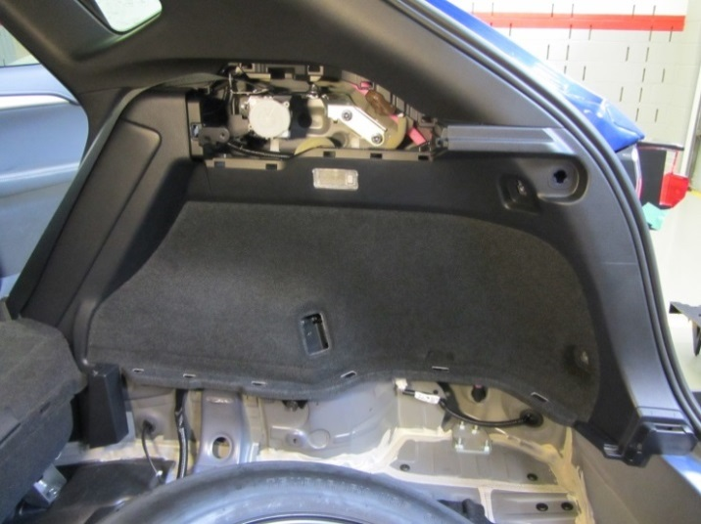
    - Disengage the nine clips to displace the deck trim side panel assembly RH (Fig. 1-27).
Fig. 1-27
  - Disconnect the electrical connectors for the cargo lamp and remove the deck trim side panel assembly RH by pulling it rewards.

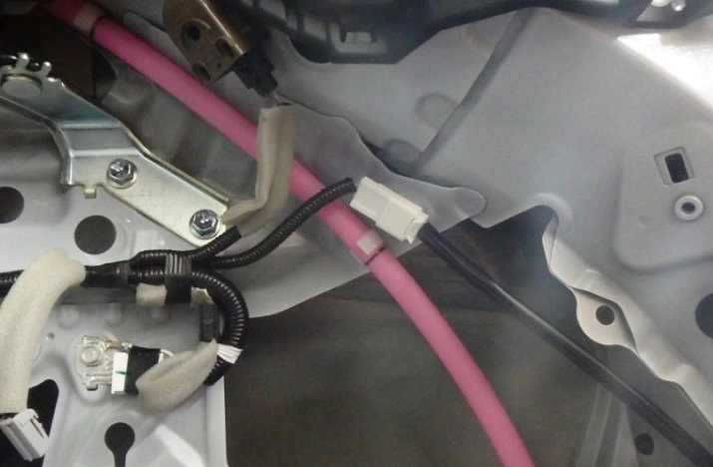
  - Disconnect the 4 pin in-line electrical connector to RH rear combination lamp assembly (Fig. 1-28).
Fig. 1-28

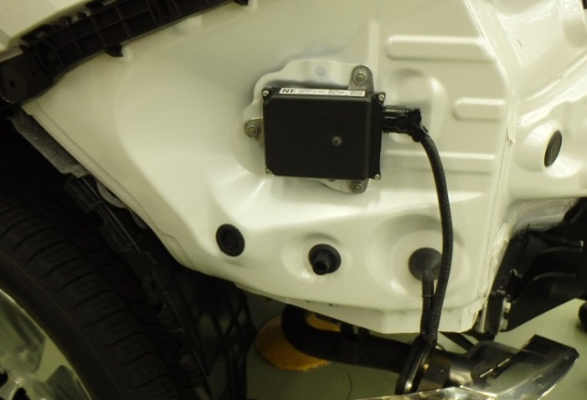
  - Remove and discard the trailer sub-wire harness pass through hole plug (Fig. 1-29).
Fig. 1-29

Install the Trailer Module Harness.
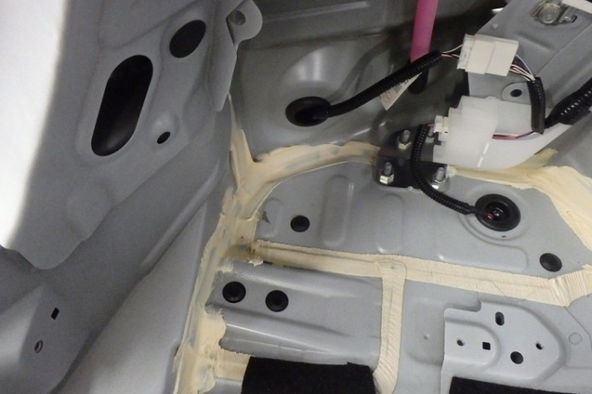
  - Locate the mounting surfaces to install the trailer wire module nearby the LH wheel house area (Fig. 2-1).
Fig. 2-1

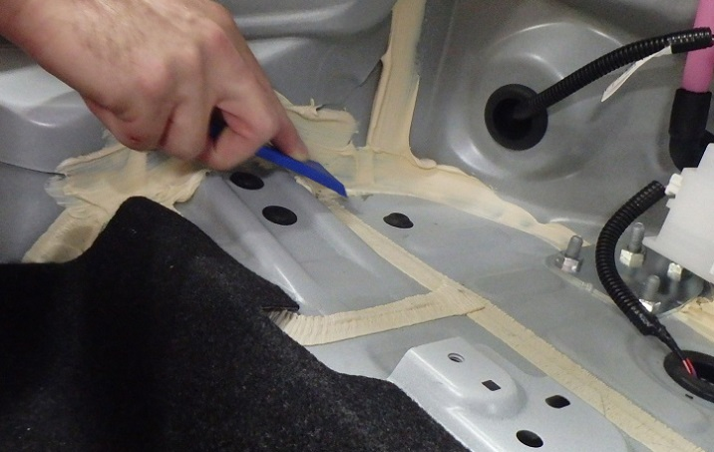
  - Scrape any body sealer that may be on the mounting surfaces (if necessary) as shown in Fig. 2-2 and clean the surfaces with VDC approved cleaner.
Fig. 2-2
Plastic scraper

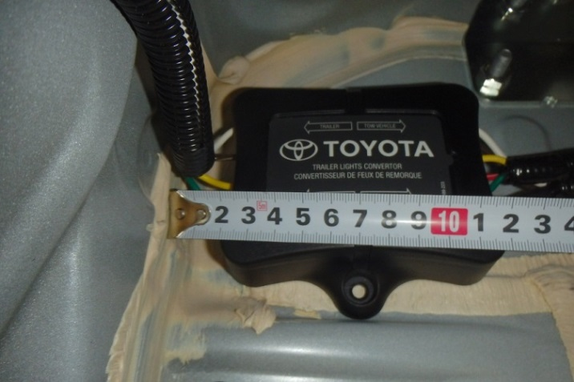
  - Determine the location of the trailer wire harness module following the dimensions below as reference (Fig. 2-3).
Fig. 2-3
Module tab
Body reinforcement
    - Approximately 20 mm away from the rear body panel.
    - Place the module side tab against the body reinforcement.
  - Peel off the double-sided tape backing strips.
  - Apply pressure and secure the module to the vehicle (Fig. 2-3).

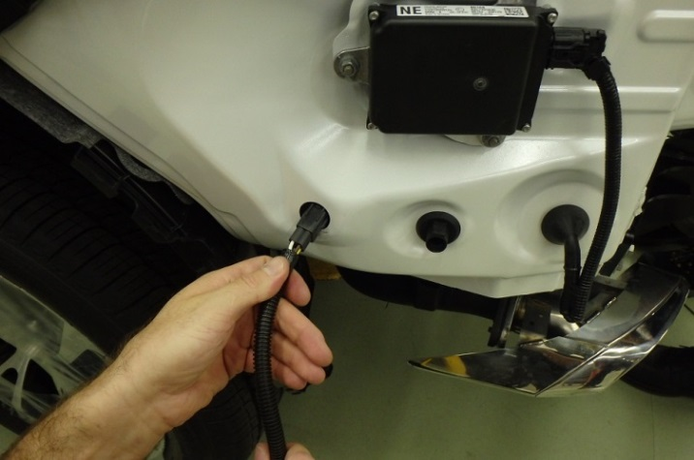
  - Pass the trailer sub-wire harness through the hole in the body (Fig. 2-4).
Fig. 2-4

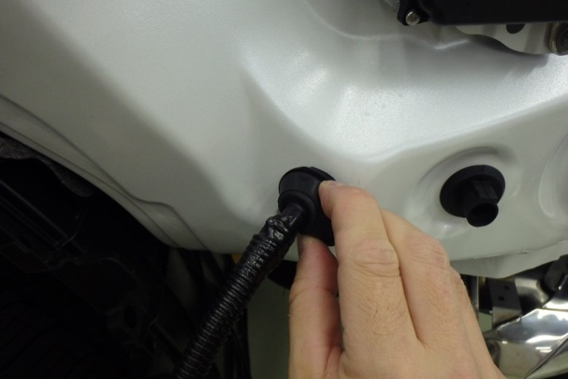
  - Insert the sub-wire grommet into the body hole (Fig. 2-5).
Fig. 2-5

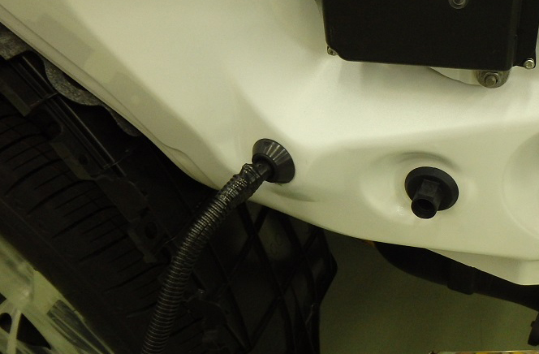
  - Make sure the grommet is fully seated to vehicle body hole (Fig. 2-6).
Fig. 2-6

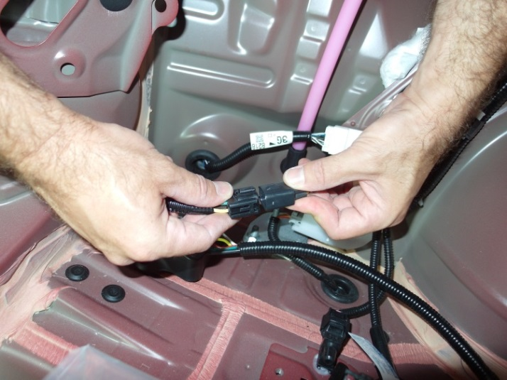
  - Connect the 4 pin in-line connector between the trailer sub-wire and module harnesses (Fig. 2-7).
Fig. 2-7
NOTE: Make sure the connectors are fully engaged.

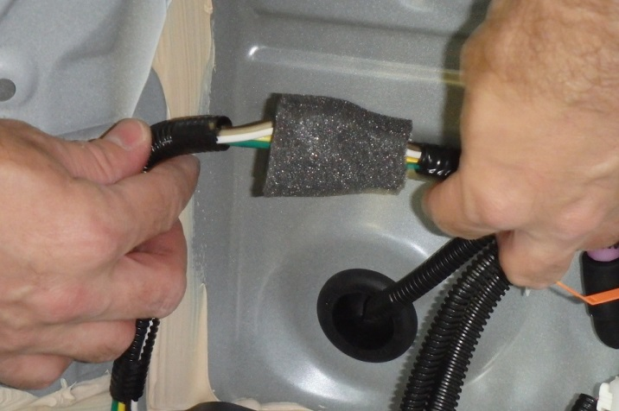
  - Wrap the 4 pin in-line connector with a piece of foam tape (Fig. 2-8).
Fig. 2-8

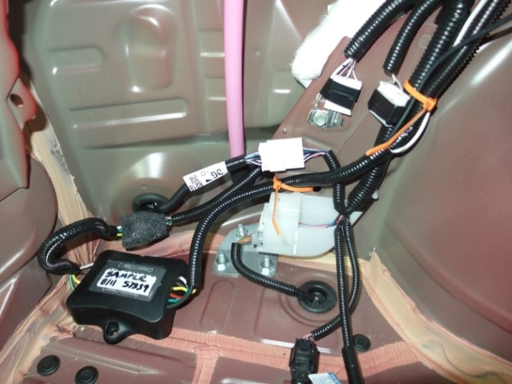
  - Start routing and securing the trailer module harness in the rear wheel house LH area (Fig. 2-9).
Fig. 2-9
1
2

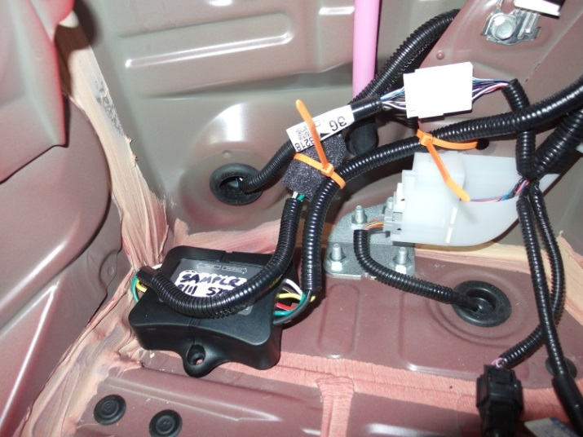
  - Secure the 4 pin in-line connector between the trailer sub-wire and module harnesses to the wire with a wire tie (Fig. 2-10).
Fig. 2-10
3

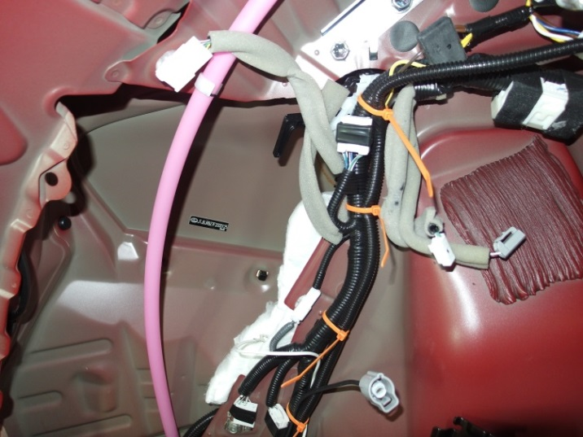
  - Continue routing and securing the trailer module harness along the vehicle wire harness (Fig. 2-11).
Fig. 2-11
4
5
6

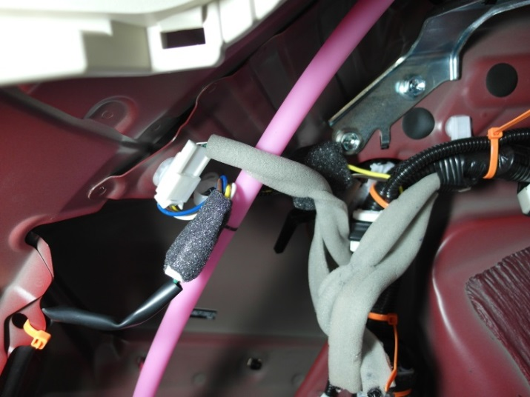
  - Connect the trailer module harness (T-type connection with yellow, brown, blue and white wires) between the rear combination lamp assembly LH pigtail and the vehicle wire harness (Fig. 2-12).
Fig. 2-12
7
Foam tape
NOTE: Route the trailer module harness behind the vehicle wire harness.
  - Wrap the in-line connector and splice joint with a piece of foam tape (Fig. 2-12).

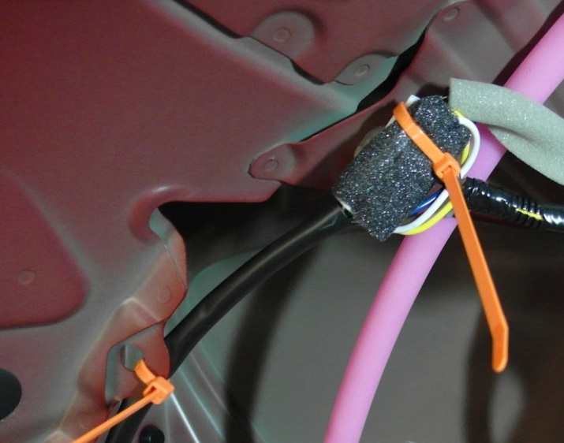
  - Secure the T-type connection to the vehicle wire harness (Fig. 2-13).
Fig. 2-13
8

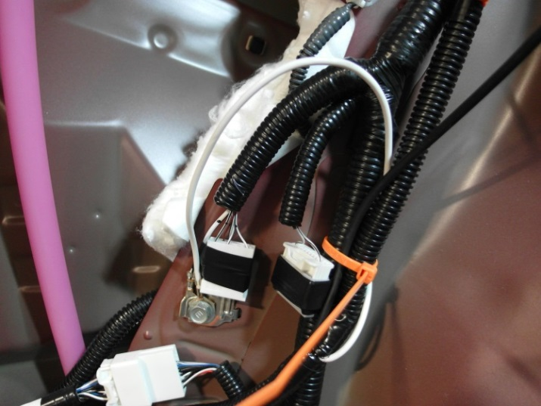
  - Attach the trailer wire ground terminal to the vehicle ground attachment (Fig. 2-14).
Fig. 2-14
10mm socket, ratchet & torque wrench
    - Use a 10mm socket to remove the ground bolt (Fig. 2-14).
    - Attach the trailer white wire with ring terminal on top of the vehicle ground terminal (green line, Fig. 2-14).
    - Reinstall the bolt and tighten it to 8.4 N•m (74 lbf•in).
Torque: 8.4 N•m (74 lbf•in)
NOTE: Make sure to reinstall all existing ground wires/terminals.
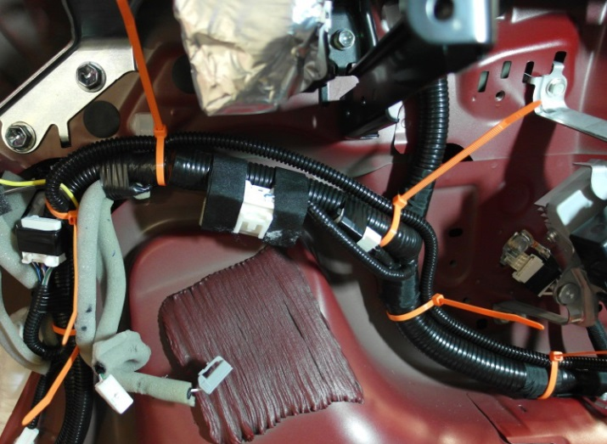
  - Route and secure the trailer module harness along the vehicle wire harness and towards the RH rear combination lamp assembly (green line, Fig. 2-15).
9
10
11
12
Fig. 2-15

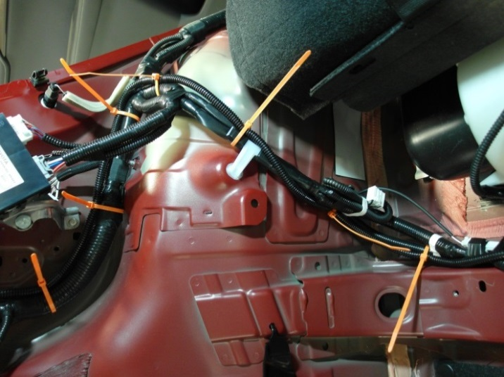
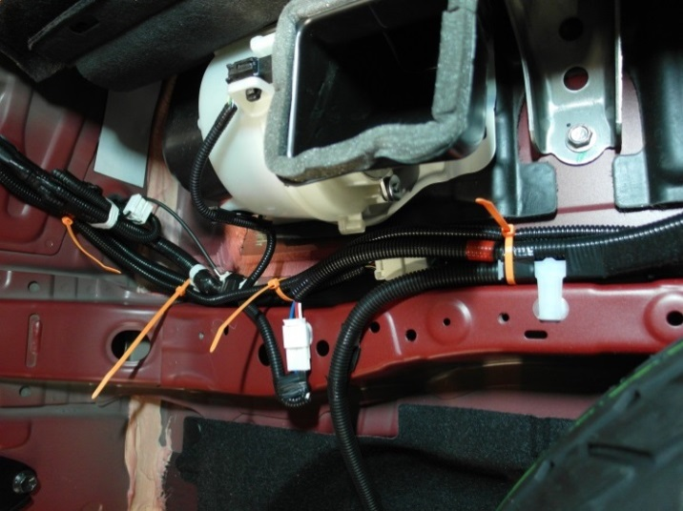
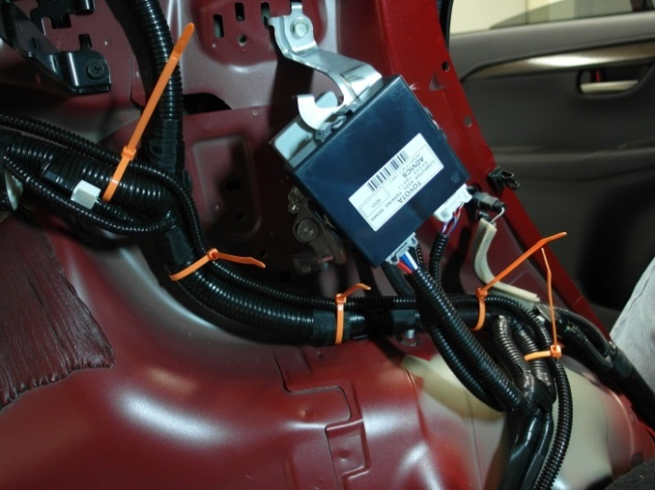
  - Continue to route and secure the trailer module harness along the vehicle wire harness and towards the RH rear combination lamp assembly (green line, Fig. 2-16 to Fig. 2-18).
15
16
Fig. 2-17
Front of vehicle

17
18
Fig. 2-18
Front of vehicle

19
14
13
Fig. 2-16
Front of vehicle

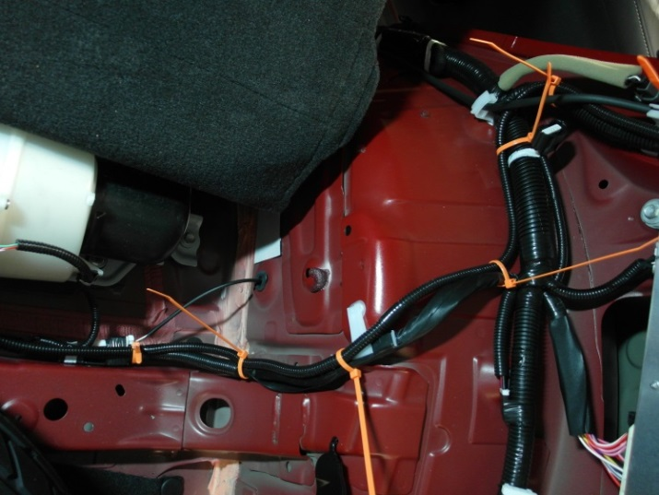
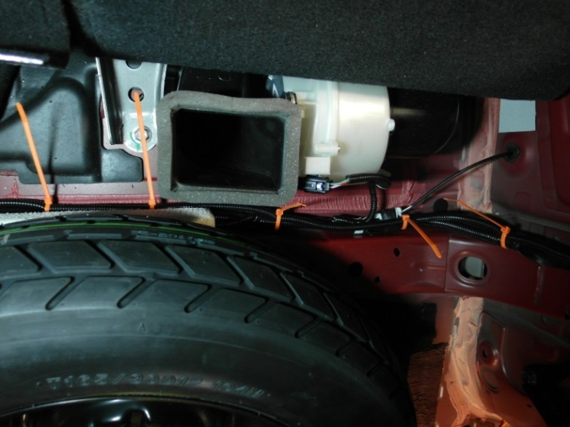
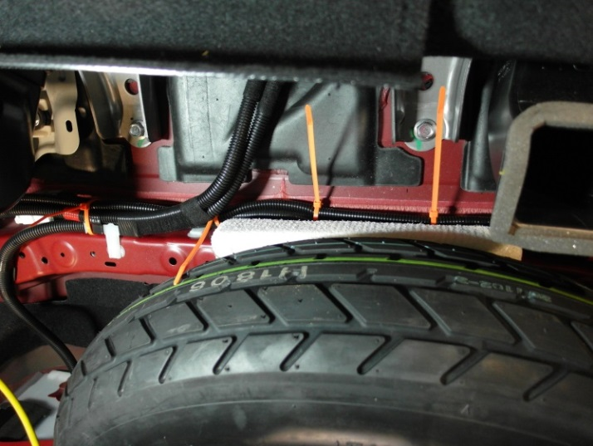
  - Continue to route and secure the trailer module harness along the vehicle wire harness and towards the RH rear combination lamp assembly (green line, Fig. 2-19 to Fig. 2-21).
28
Fig. 2-21
26
27
Drain hose
29
25
Fig. 2-20
23
24
Front of vehicle

20
Fig. 2-19
21
22

NOTE: Do not secure the trailer module harness to the vehicle drain hose. Secure the harness to the vehicle wire harness only (Fig. 2-21).

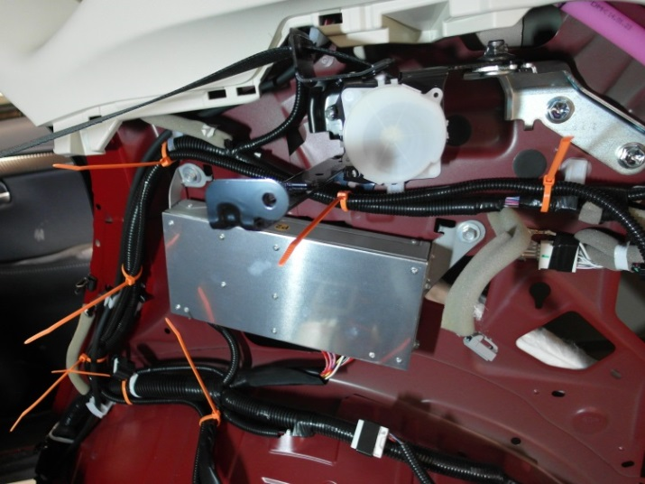
  - Finish routing and securing the trailer module harness along the vehicle wire harness and towards the RH rear combination lamp assembly (green line, Fig. 2-22).
32
Fig. 2-22
30
31
Front of vehicle

33

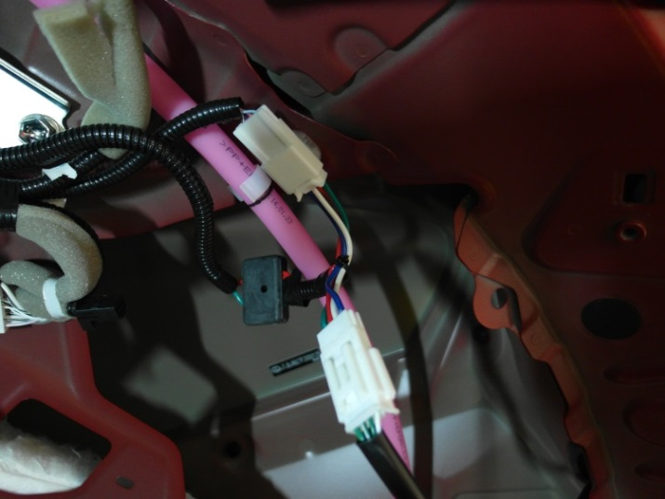
  - Connect the trailer module harness (T-type connection with red, green, blue and white wires) between the rear combination lamp assembly RH pigtail and the vehicle wire harness (Fig. 2-23).
Fig. 2-23

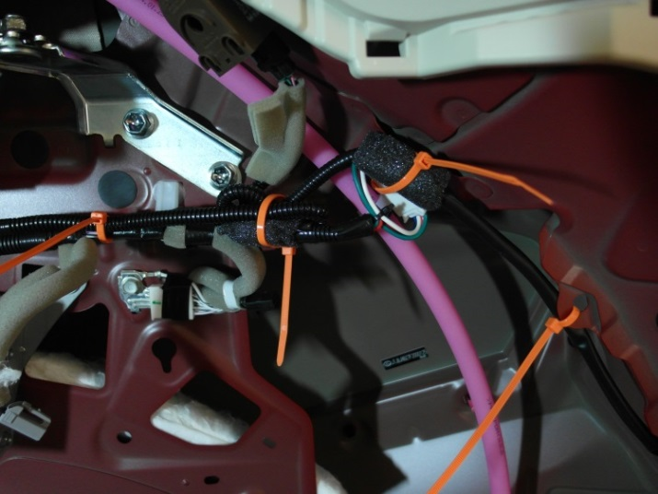
  - Wrap the in-line connector and splice joint with a piece of foam tape, then secure it to the vehicle wire harness as (Fig. 2-24).
Fig. 2-24
34
36
4 pin connector to RH rear comb lamp

35

Install the Trailer Power Wire.
  - Install the B+ terminal from the trailer power wire to the positive battery cable/terminal.
    - Locate the provided trailer power wire harness.
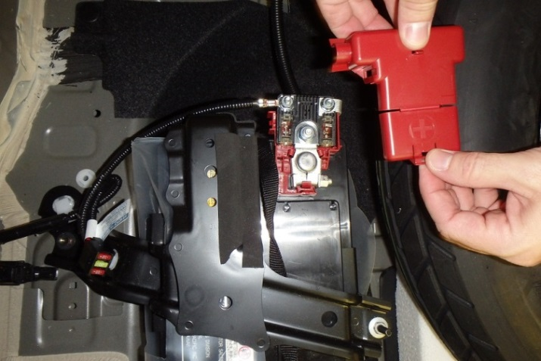
    - Locate and uncover the B+ battery post (Fig. 3-1).
Fig. 3-1

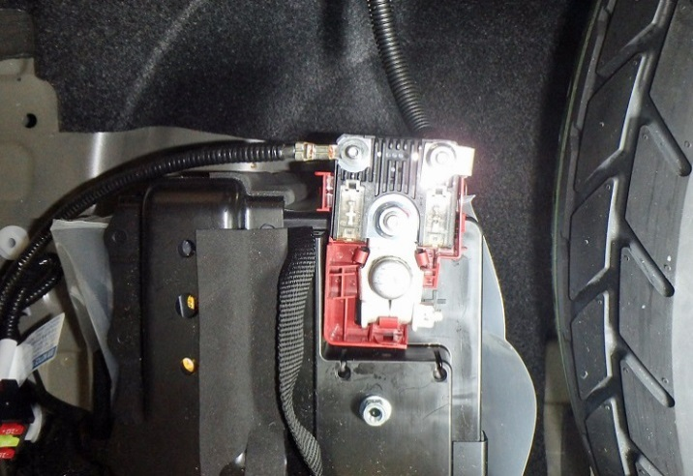
    - Remove the M6 nut from the positive battery cable high current fuse (Fig. 3-2).
Fig. 3-2
10mm socket, extension & ratchet
NOTE: Do not touch the positive terminal with any tool when removing the negative battery cable.

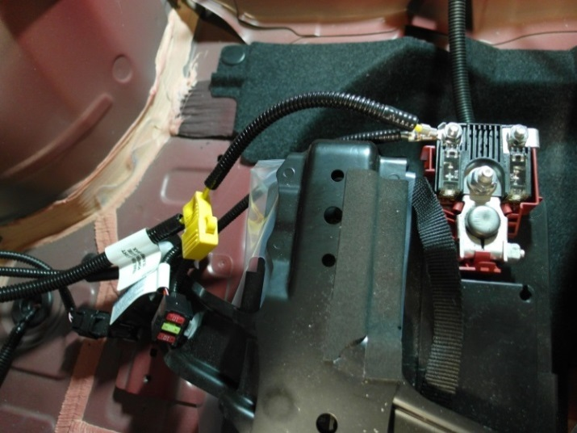
    - Attach the trailer power wire ring terminal to battery terminal on the top of the vehicle wire ring terminal (Fig. 3-3).
Fig. 3-3
10mm socket & torque wrench
NOTE: Make sure to position the ring terminal so that the protective cover can be reinstalled over the post.
    - Reinstall the M6 wire nut and torque it to 6.5 N•m (58 lbf•in).
Torque: 6.5 N•m (58 lbf•in)

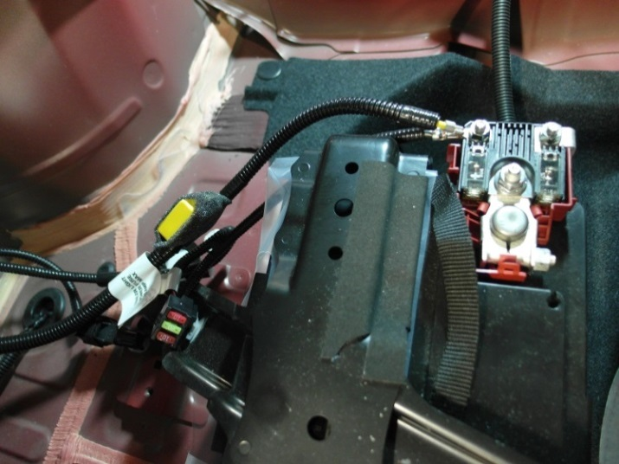
  - Wrap the fuse holder with a piece of a foam tape (Fig. 3-4).
Fig. 3-4

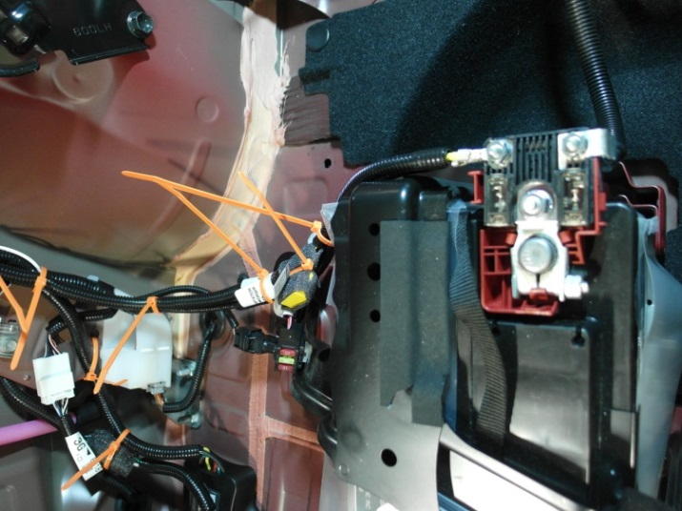
  - Route and secure the trailer power wire along the vehicle wire harness (Fig. 3-5).
Fig. 3-5
39
37
41
40
38

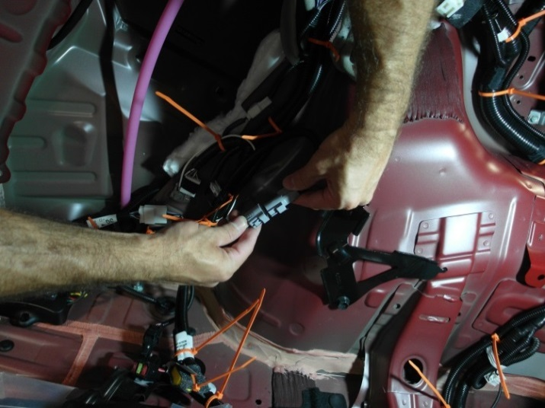
  - Connect the 1 pin in-line connector between the trailer power wire and the module harnesses (Fig. 3-6).
Fig. 3-6
NOTE: Make sure the connectors are fully engaged.

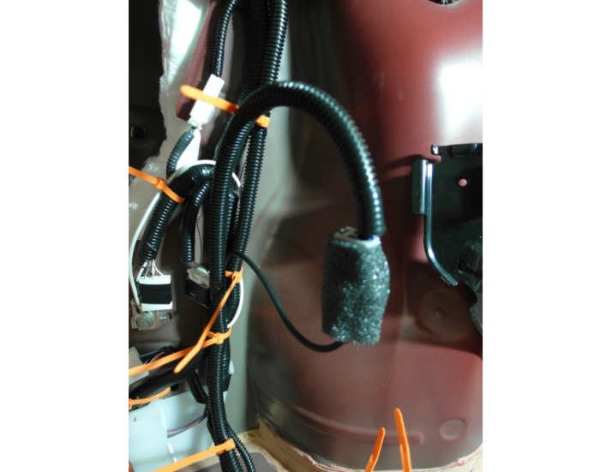
  - Wrap the 1 pin in-line connector with a piece of foam tape (Fig. 3-7).
Fig. 3-7
Foam tape

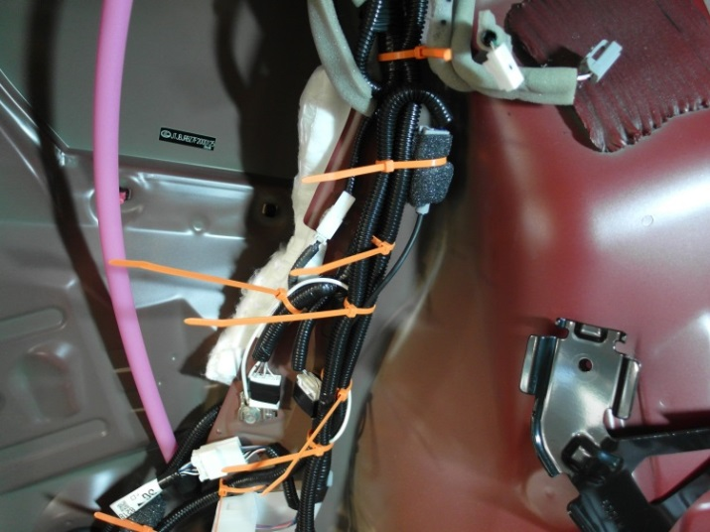
  - Secure the power wire to the vehicle wire harness (Fig. 3-8).
Fig. 3-8
42
43

Install the Trailer Sub-Wire Harness.

NOTE: Install the tow hitch before proceeding with next steps (PLEASE REFER TO THE TOW HITCH INSTALLATION INSTRUCTIONS). Do not reinstall the rear bumper fascia until completing the trailer sub-wire harness installation.
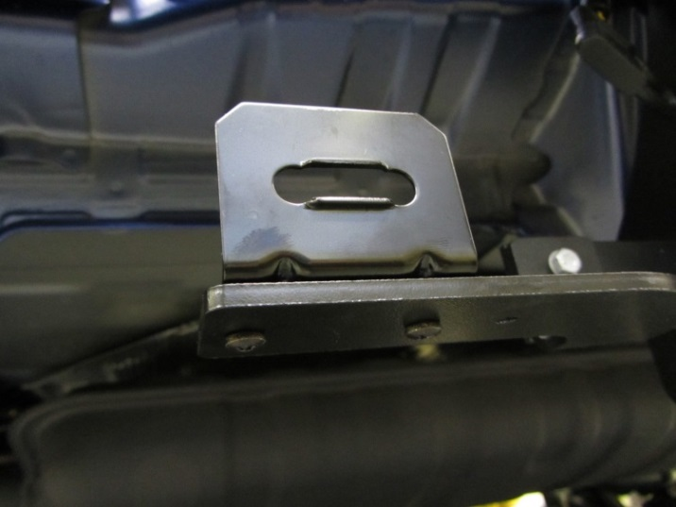
  - Use two sets of provided screws and nuts/washers to attach the L-shaped bracket for the trailer connector into the hitch bracket (Fig. 4-1).
Fig. 4-1
10mm socket & Phillips screwdriver

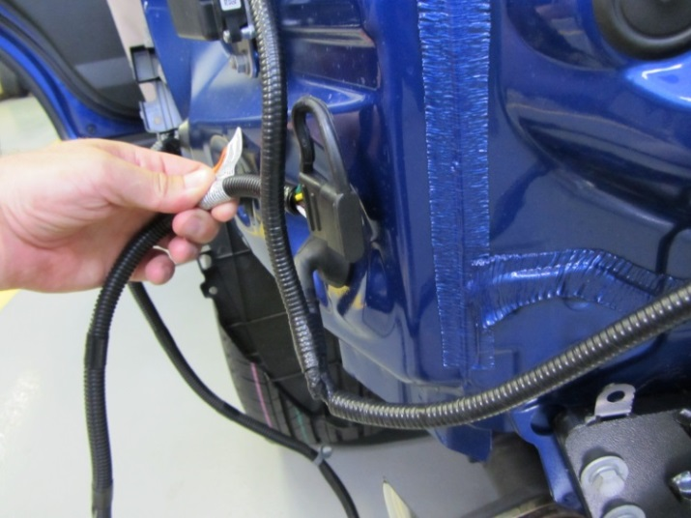
  - Pass the trailer sub-wire harness inside the vehicle wire harness for the blind spot monitoring system LH (if equipped) (Fig. 4-2). For vehicles without the blind spot monitoring system, route the harness in the same manner.
Fig. 4-2
  - Route the trailer sub-wire harness along the top of the hitch crossbar towards the passenger side.

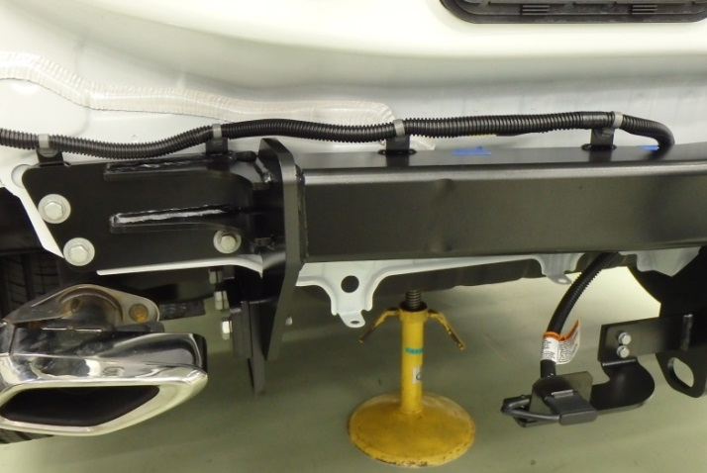
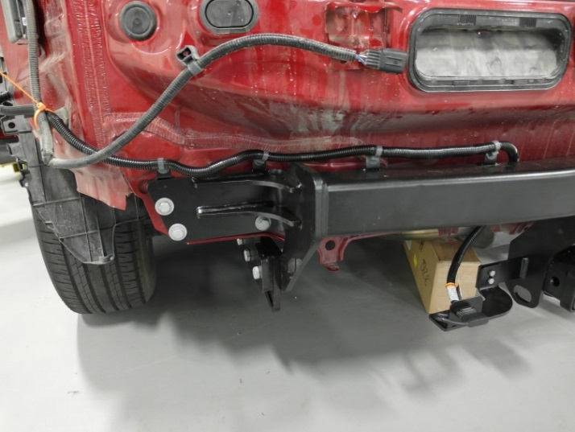
  - Secure the sub-wire to the hitch by inserting all four push mount clips to the tabs on top of the hitch (Fig. 4-3 and Fig. 4-4).
Fig. 4-4
Push mount clip
Fig. 4-3
44
  - Secure the trailer sub-wire harness to the vehicle wire harness with one wire tie (Fig. 4-3).
  - Insert the trailer connector (4-Flat) to the bracket mounted on the hitch support (Fig. 4-4).
  - Cut the excess of all wire ties used to secure the trailer wire harnesses.

Complete the Installation.
  - Reinstall the vehicle parts in reverse order of removal.
  - Prepare the bumper under cover LH for reinstallation.
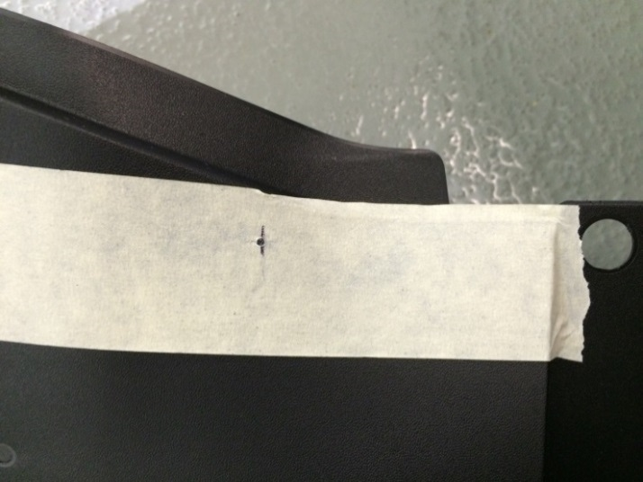

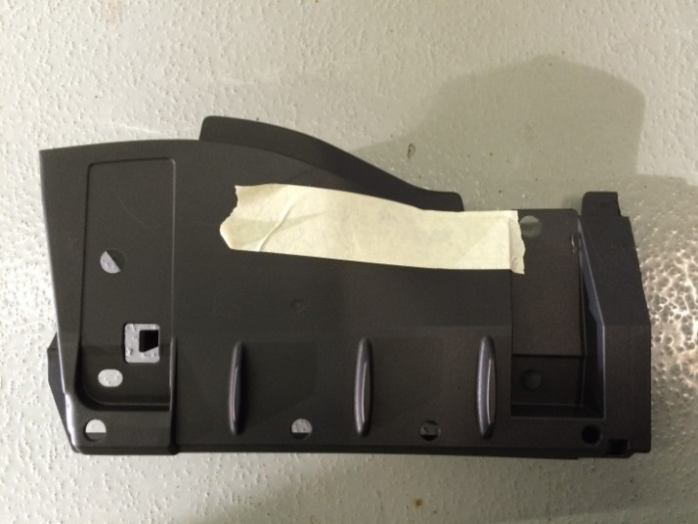
    - Use a 14 mm (9/16”) bit to drill the under cover LH in the position shown in Fig. 5-1 and Fig. 5-2.
Fig. 5-2
75 mm
10 mm
14 mm diameter
Drill & 14 mm (9/16”) bit
Fig. 5-1
HINT: Tape the tray with masking tape to mark the hole position and prevent scratches on the plastic tray.

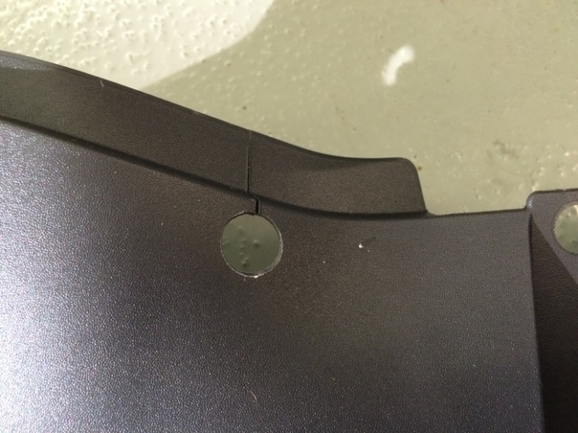
    - Cut the under cover from the drilled hole to the edge as indicated by the dotted line in Fig. 5-3.
Fig. 5-3
Metal saw

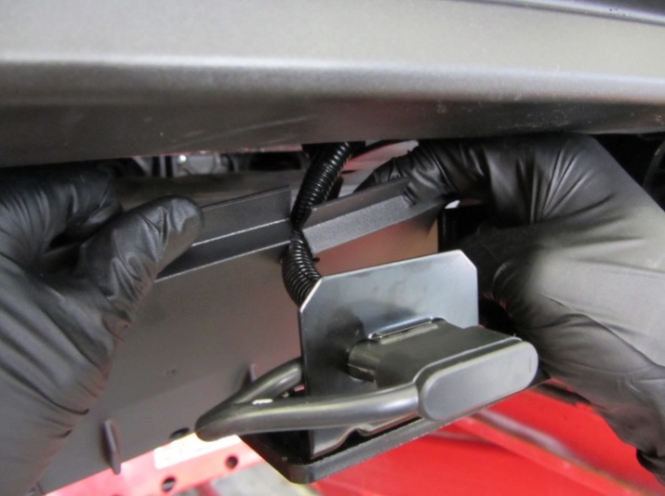
    - Pass the trailer sub-wire harness through the cut from the previous step and place the bumper under cover LH in position for reinstallation (Fig. 5-4).
Fig. 5-4

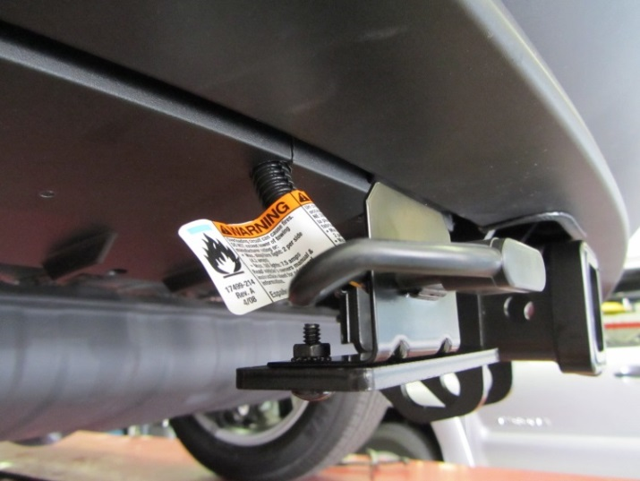
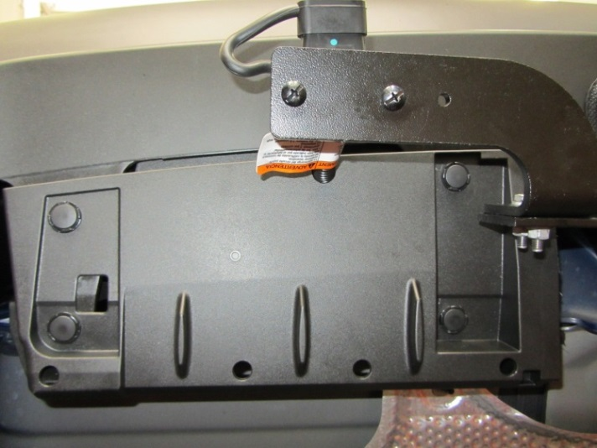
  - Reinstall the bumper under cover LH (Fig. 5-5 and Fig. 5-6).
Fig. 5-6
Fig. 5-5
  - Verify the trim panels fit together properly with no uneven gaps.
  - Reinstall the vehicle’s negative (-) battery terminal to the battery and install the DCC fuse if required.
Torque: 5.4 N•m (48 lbf• in).
NOTE: Do not touch the positive terminal with any tool when installing the negative battery cable.

Accessory Function Checks
Right turn signal
Left turn signal
Brake
Tail light
Tail light & brake
Left turn & brake
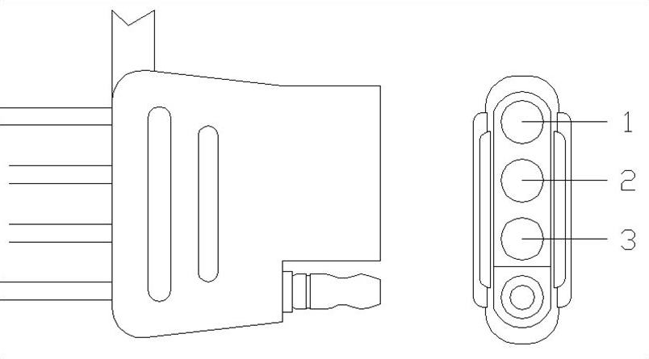
Right turn & brake

Vehicle Function Checks
Individual vehicle light functions

Trunk light
Warning lights

Circuit 1 flashes
Circuit 2 flashes
Circuit 1 & 2 activate
Circuit 3 activates
Circuit 1, 2 & 3 activate
Circuit 1 activates & 2 flashes
Circuit 1 flashes & 2 activates

Verify that the corresponding vehicle lights activate. If light does not activate then check the connection.
Functions normally
No warning lights illuminated in the combination meter

Vehicle Appearance Check
After accessory installation and removal of protective cover(s), perform a visual inspection.

Ensure no damage (including scuffs and scratches) was caused during the installation process.
(For PPO installations, refer to TMS Accessory Quality Shipping Standard.)

Failure Mode
- No power to the trailer light functions

- Corrosion on the 4-flat plug

Troubleshooting Steps
- Check the trailer wiring harness fuse per the owner’s manual fuse location card.
- Check the 4-flat connection between the trailer and the vehicle to ensure the connection is fully engaged.
- Turn all functions off and remove the key for 10 seconds and retest the functions with the trailer attached.
- Turn all functions off and remove the key for 10 seconds with the trailer disengaged. Use a multi-meter to check the function output at the 4-flat. If all functions work, check the trailer for a potential short or overload described in the owner’s manual fuse location card.

- Clean the connection and add Dielectric Grease (sold separately) to the terminal pins.

